Homework
Due Monday 7th December
Spellings:

category
muscle
identity
individual
interfere
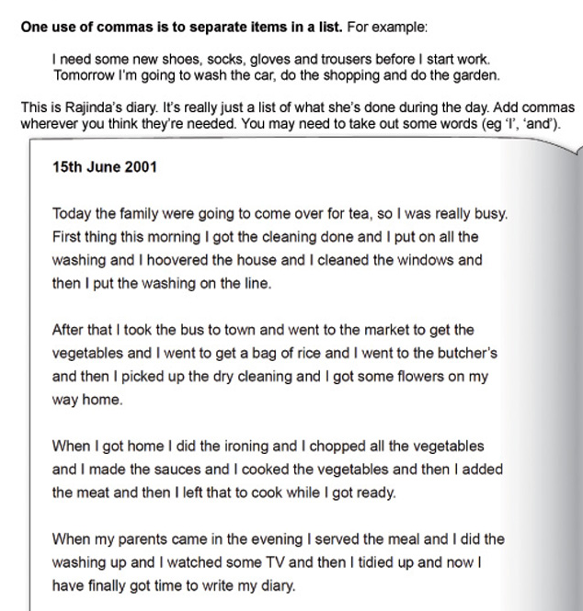

2nd December 2015

round
around
ground
about
shouted

