Y5 Homework
18.1.17 (to be handed in 23.1.17)
Spellings
We are revising spellings which you should already have learnt in Y3/4 and we are going to learn them as part of a class competition! Every week, you will have 10 spellings to learn. We will then test them in class and collect the total score. Which Y5 class will score the highest?
accident
actual
address
answer
appear
arrive
believe
bicycle
breath
breathe

Maths
Your maths homework has been given to you as a separate booklet. These are being sent home to ensure that you know your multiplication facts. If you already know them all, time yourself to see how long it takes you to complete the booklet and see if you can improve each week.

Writing
We have been revising how to use commas for lists, relative clauses and fronted adverbials. Here’s an example for each:
List- I can’t believe that I ate 4 potatoes, 3 Yorkshire puddings, 2 sausages and all of my peas for dinner.
Fronted adverbial-Like rubies in an exquisite bracelet, the coral sparkled in the sunshine.
Relative clause-Lions lazed under the tree, which provided vital shelter from the midday sun.

We have looked at how to correct mistakes and add commas to make sure our work makes sense. Sometimes a missing comma makes something very funny!

How could a comma change the meaning of this sentence?

The kids who got ice cream were very happy Look at that huge hot dog
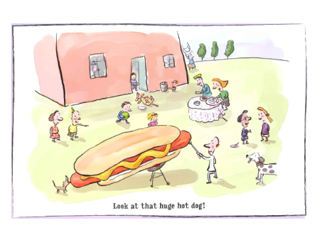
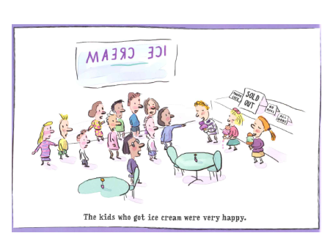

What would the picture look like if you changed the meaning using commas? Draw one for each.
As a challenge, you could write your own examples to see how you can change the meaning – the funnier the better!

Y5 Homework
18.1.17 (to be handed in 23.1.17)
Spellings
We are revising spellings which you should already have learnt in Y3/4 and we are going to learn them as part of a class competition! Every week, you will have 10 spellings to learn. We will then test them in class and collect the total score. Which Y5 class will score the highest?
accident
actual
address
answer
appear
arrive
believe
bicycle
breath
breathe

Maths
Your maths homework has been given to you as a separate booklet. These are being sent home to ensure that you know your multiplication facts. If you already know them all, time yourself to see how long it takes you to complete the booklet and see if you can improve each week.

Writing
We have been revising how to use commas for lists, relative clauses and fronted adverbials. Here’s an example for each:
List- I can’t believe that I ate 4 potatoes, 3 Yorkshire puddings, 2 sausages and all of my peas for dinner.
Fronted adverbial-Like rubies in an exquisite bracelet, the coral sparkled in the sunshine.
Relative clause-Lions lazed under the tree, which provided vital shelter from the midday sun.

We have looked at how to correct mistakes and add commas to make sure our work makes sense. Sometimes a missing comma makes something very funny!

How could a comma change the meaning of this sentence?

The kids who got ice cream were very happy Look at that huge hot dog

What would the picture look like if you changed the meaning using commas? Draw one for each.
As a challenge, you could write your own examples to see how you can change the meaning – the funnier the better!

